Component Level Interaction

Create Child component: ng g c child

Open child.component.ts

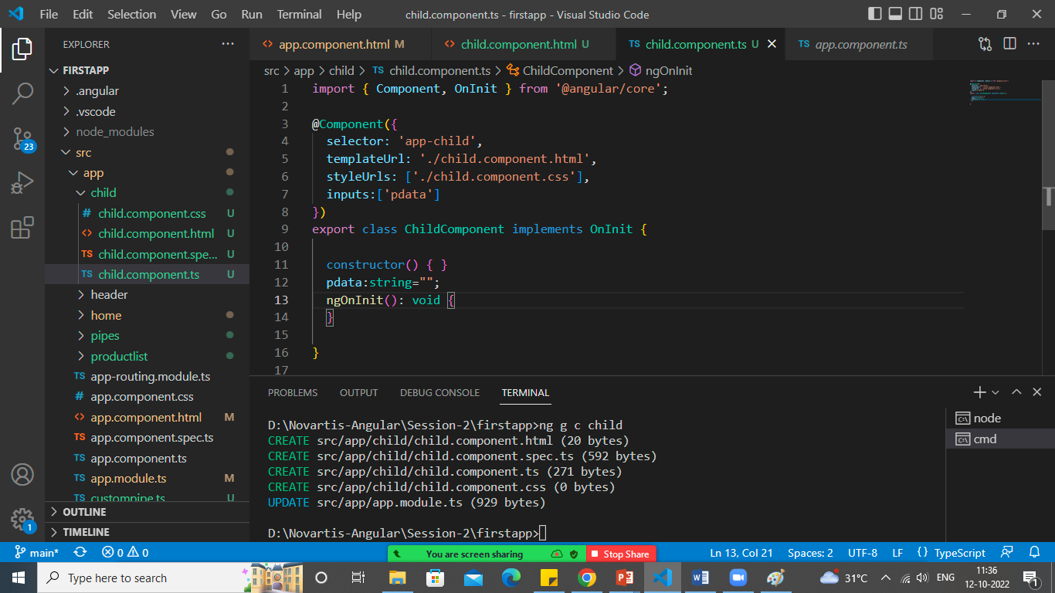

Declare pdata variable and add the same in input decorator.

Display Value in child.component.html

<h1>This is Child Component</h1>

<p>Value coming from Parent Component: {{pdata}}</p>

Add child component to app.component.html and also add keyup event

<h1>This is My Parent Component</h1>

<input type="text" (keyup)="0" #ptext>

<app-child [pdata]="ptext.value"></app-child>

Let’s Do Child to Parent Communication

Child.component.html

<h1>This is Child Component</h1>

Enter Any Text:<input type="text" #cmessage (keyup)="sendData(cmessage.value)"/>

<br>

<p>Value coming from Parent Component:</p>

    <p>Welcome: {{pfname}}  {{plname}}</p>

    <p>Your Registered Email:  {{pemail}}</p>

Child.component.ts

import { Component, OnInit,EventEmitter } from '@angular/core';

@Component({

  selector: 'app-child',

  templateUrl: './child.component.html',

  styleUrls: ['./child.component.css'],

  inputs:['pemail','pfname','plname'],

  outputs:['cevent']

})

export class ChildComponent implements OnInit {

  constructor() { }

  pemail:string="";

  pfname:string="";

  plname:string="";

  ngOnInit(): void {

  }

  cevent= new EventEmitter<string>();

  sendData(value:string){

    this.cevent.emit(value);

  }

}

App.component.html

<h1>This is My Parent Component</h1>

<p>Value coming from Child Component: {{cdata}}</p>

Enter Email: <input type="text" (keyup)="0" #pemail><br>

Enter FirstName: <input type="text" (keyup)="0" #pfname><br>

Enter LastName:<input type="text" (keyup)="0" #plname><br>

<app-child [pemail]="pemail.value"

[pfname]="pfname.value"

[plname]="plname.value"

(cevent)="cdata=$event"

></app-child>

App.component.ts

export class AppComponent {

  title = 'firstapp';

  cdata:string="";

}